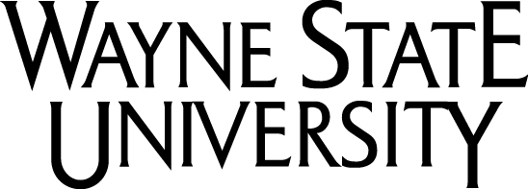
Post-doctoral Fellow Position

The Life-Span Cognitive Neuroscience Program at the Institute of Gerontology (IOG; www.iog.wayne.edu), Wayne State University (WSU) invites applications for a Post-doctoral Fellow position in the area of LIFE-SPAN COGNITIVE NEUROSCIENCE.

Applicants should have a Ph.D. in a relevant discipline, such as Psychology, Neuroscience, or related areas and must be US citizens or lawful permanent residents. The goal of this two-year position is to enable a successful applicant to develop a coherent research program.

We seek applicants with research interests and skills relevant to longitudinal life-span studies of cognitive and brain development. The prerequisites are strong record of experience with noninvasive neuroimaging, working knowledge of multivariate statistical methods. The fellow will work with Drs. Noa Ofen (ofenlab.wayne.edu) and Naftali Raz (agingbrain.wayne.edu) in the Life-Span Cognitive Neuroscience program. Our current research focuses on longitudinal studies of structural and functional brain changes, their impact on cognition and modification of that relationship by genetic variants. We are particularly interested in memory and in the impact of vascular risk factors on the course of brain aging and development. The successful candidate will be expected to conduct independent and collaborative research, disseminate research findings in top-tier journals and at major conferences, engage in the mentoring of graduate and undergraduate students, and contribute productively to the Life Span Cognitive Neuroscience at Wayne State University.

Wayne State University is one of the nation’s pre-eminent public research centers and is a nationally recognized Carnegie Level-I research university, and is ranked by NSF among the top 50 public research universities in total R&D expenditures. Wayne State is committed to development of innovative approaches to neuroscience and supports a state-of-the art MRI Research Center with an outstanding staff of physicists and technologists dedicated to research and development.

Applicants should send application materials to Naftali Raz (nraz@wayne.edu) and Noa Ofen (noa.ofen@wayne.edu). Please attach your curriculum vitae, a brief description of research interests, at least three relevant peer-reviewed publications, and the names and contact information for three references by January 1, 2014.

Wayne State University is an Affirmative Action Recruiter / Equal Opportunity Employer and qualified candidates from minority groups are particularly encouraged to apply.

